**Lincoln Takes Over DETV: Putting Our Major in Motion**

**A Day of Learning and Exploration for LU Mass Comm Students**

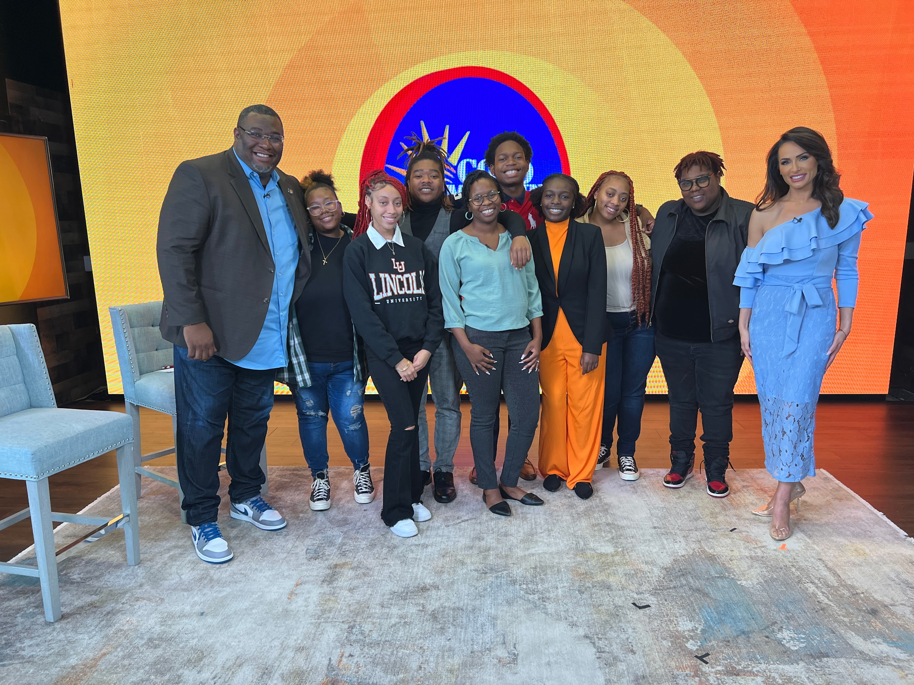

Lincoln University Mass Communication students after Goodmorning Wilmington live show. From left to right Ivan Thomas, Owner and Host for DETV, Danielle Vignovich, Kyrah Page, Soyica Littman, Professor Joy McFadden, Eusebio Refuse Jr. Vivica Mitchell, Danielle West, Vincenza Carrieri-Russo, Host on DETV

**By: Kyrah Page**

**Published December 10, 2023**

In an exciting and educational endeavor, students from Lincoln University's Mass Communications Department had the amazing opportunity to visit the set of 'Good Morning Wilmington' on DETV. This experience not only offered us a glimpse into the world of broadcasting but also provided valuable insights for us aspiring mass communication professionals.

Hosted by Ivan Thomas and Vincenza Carrieri-Russo, "Good Morning Wilmington" is a well-known morning show that offers a variety of educational and entertaining content to a broad local audience in the state of Delaware. This show covers a range of topics, such as current events, news, entertainment, and activities taking place in the community.

The opportunity to see a well-known successful local television program's behind-the-scenes operations provided a unique educational experience for us. Upon entering the studio, we were greeted and welcomed by the team of people who work tirelessly to make 'Good Morning Wilmington' possible every day. We were then told that we were to be the live audience for their show for that day.

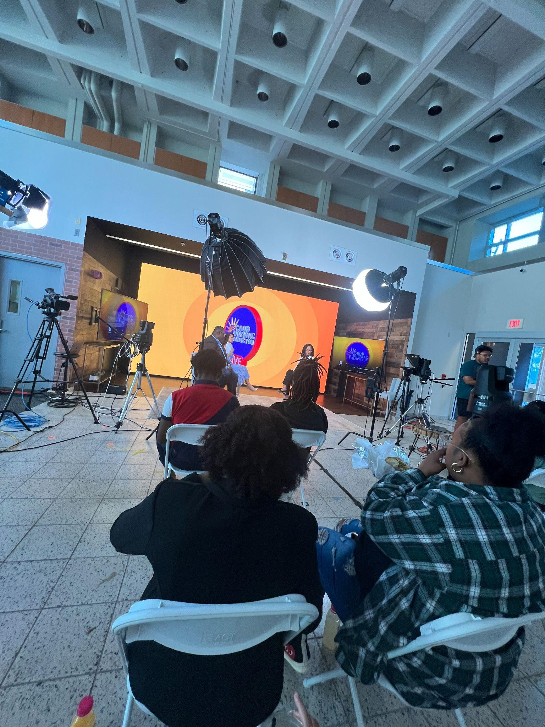

Sitting in the audience not only allowed us to see the inner workings of what goes into live producing 'Good Morning Wilmington,' but we also had the opportunity to actively participate and ask questions. While sitting in the audience was an amazing experience, I think I can speak for all the students present that the most valuable part of this trip was being able to have a one-on-one with the faces and the team of 'Good Morning Wilmington.'

As soon as the show ended, everyone gathered around and allowed us to ask as many questions as we could. Mr. Ivan and Ms. Vicenza did an incredible job answering our questions while being a bit vulnerable with us about the journey that got them to where they are now. It was inspiring to hear and made us students want to further connect and inquire about internships.

This close interaction with the professionals behind the scenes provided us with real-world insights into the challenges and triumphs of working in the local broadcasting industry. The opportunity to witness the live production process and engage with the team directly fueled our passion for pursuing careers in mass communication. What was even more inspiring was that despite how small the team was not only were they successful, but they had made such a huge impact. You do not have to have a team of a thousand people to make things happen.

On behalf of the Mass Communications students who were present on this trip, allow me to thank Professor McFadden and the Mass Communications department for providing real-world opportunities for hands-on learning experiences in our field.

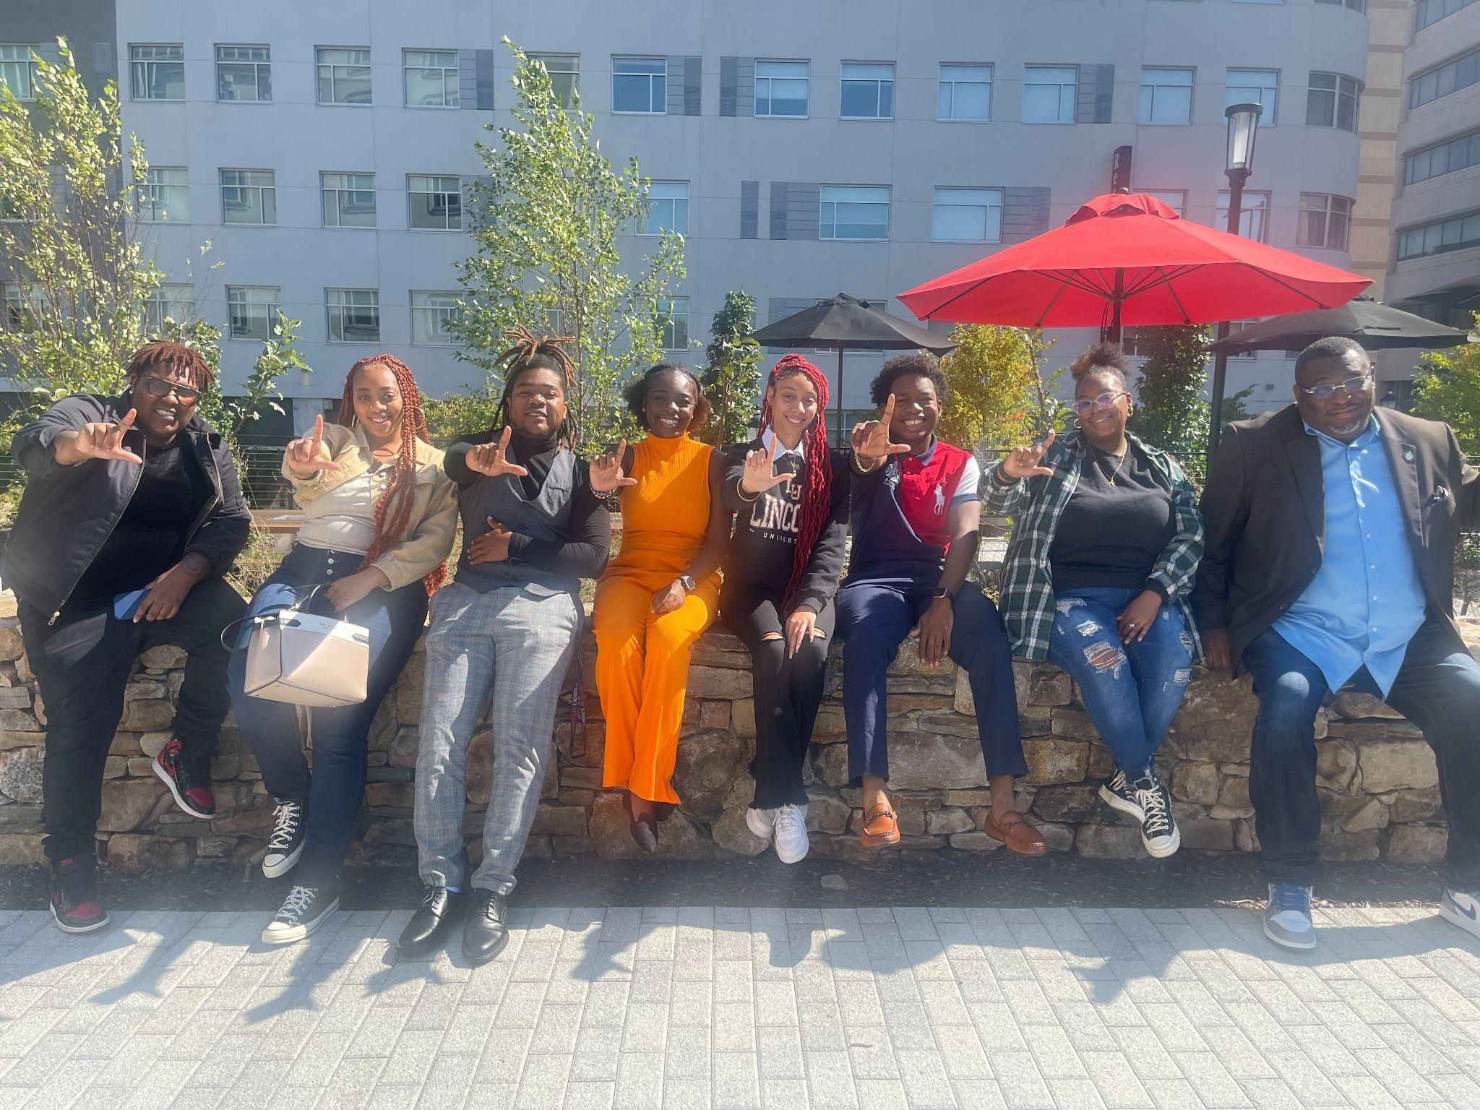

In conclusion, the visit to the set of 'Good Morning Wilmington' was not only an educational experience but also a source of inspiration for the students from Lincoln University. The hands-on experience with the inner workings of a local morning show and the candid conversations with the hosts and team members left a lasting impression, reinforcing our commitment to the field of mass communication and the exciting possibilities it holds.