**Talented Lincoln Lion Excels Above and Beyond Lincoln, PA by Ke’Vaughn James**

In the heart of Lincoln's University, a rising star is making headlines not only on the volleyball court and in the classroom but also with their exceptional musical talent. Meet Kendra Williams, a remarkable student who shows her versatility and excellence.

As a dedicated biochemistry major, Kendra has demonstrated an unyielding commitment to their studies. The demanding coursework of biochemistry is a testament to their determination and intellectual capability. However her story doesn't end there. Beyond the confines of the laboratory, Kendra exhibits their incredible athletic skills as a key player on the Lincoln University Women volleyball team. Known for their agility and finesse, Kendra has been an essential part of the team's success. Kendra’s leadership on the court does not go unnoticed by both teammates and coaches.

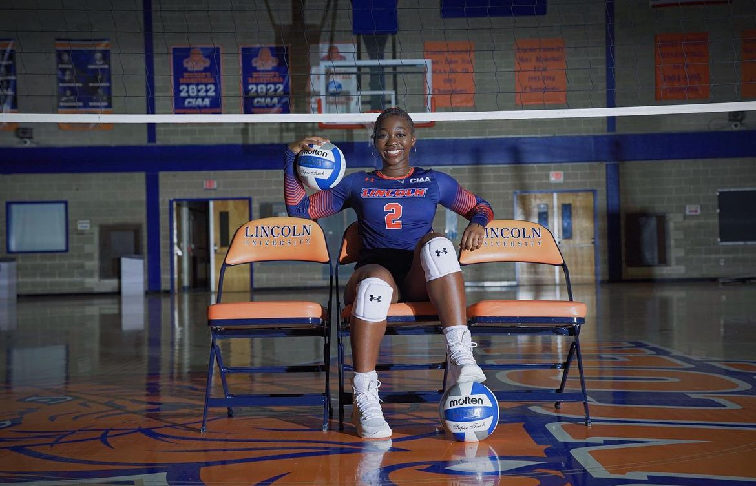

The most surprising and delightful revelation about Kendra is the musical talent. When she's not hitting the books or spiking volleyballs, Kendra graces audiences with her singing talent. Her vocal performances have been the talk of the campus, with friends and fellow students flocking to witness her extraordinary talent during campus events such as the talent show.

Kendra has many aspirations, but other than being an artist she wants to be an “ultrasound tech because i've always wanted to be a doctor of some sort and i've realized that i’d really like working in a field around babies and women like me”.

Queda Martin, the manager of the volleyball team describes Kendra as a, “ humble, kindhearted, and ambitious. Although she doubts herself, her loved ones around her keeps her determined.”

As Kendra Williams continues to impress both academically and athletically, there is no doubt that their name will soon be synonymous with success and talent not only with the Lincoln University community but beyond. Watch out for this multi-talented student as they continue to shine.